How do I make my fairy lights work?

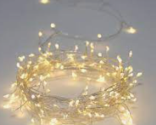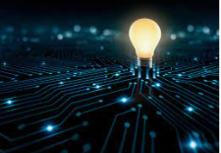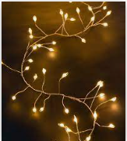

What is electricity? What would it be like to live in a world without electricity?

During this ‘electrifying’ project, children will begin to understand the importance of electricity, where it comes from and how to be safe around this valuable source of power. They will learn what is meant by the term ‘device’ and will explore how devices can be classified as being either electrical or mechanical. But do all electric devices get their electricity in the same way? Why do we have to plug some devices into the wall when others just work when we press a button or push switch?

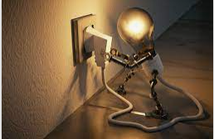

This project provides lots of opportunities for our young scientists to explore everyday electrical devices both inside the classroom and around the school building. But where does all this the electricity come from? And what happens to the electricity when devices are turned off? By asking scientific questions, the children will build upon their knowledge of electrical devices by learning about circuits and how they deliver or stop electricity from reaching devices. They will learn that electrical devices are turned ‘on’ when a circuit is connected (closed), and are turned ‘off’ when the circuit is broken (open). As they become familiar more with the parts and functions of circuits, (including switches, wires, bulbs and batteries) they will have the opportunity to build and tinker with their own.

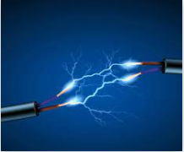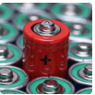
Within the project the children will have the opportunity to explore an exciting new resource called Logiblocs and will be able to use scientific vocabulary to describe how they have made their circuits and to explain how they operate.

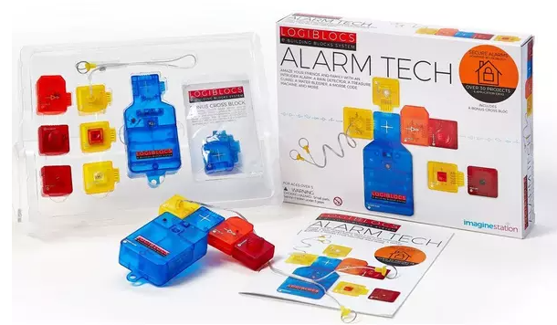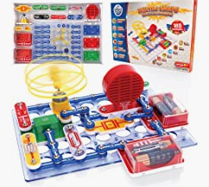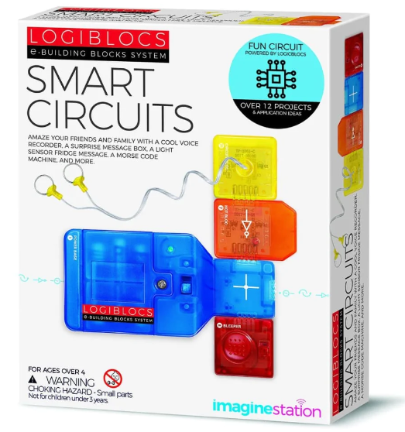
As always, we will immerse the children in the project’s theme, and the environment will inspire the children’s imagination as they pretend to be at an electrician’s workshop! We will have lots of ‘loose parts’ for them to explore and ‘fix’ as they learn how to make a circuit and which batteries to use to make the toys work - lots of problem solving opportunities!

In the book corner there will be a range of fiction and non-fiction books as well as our project stories:
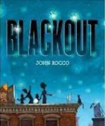
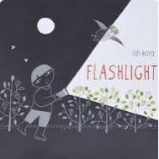
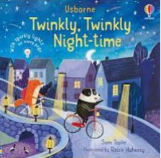
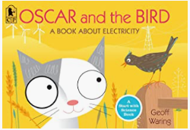
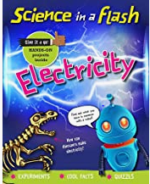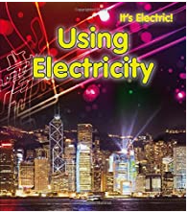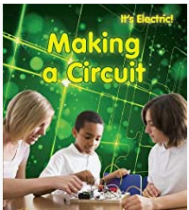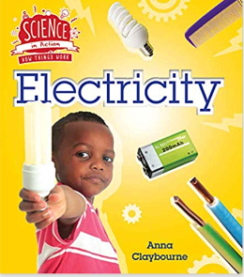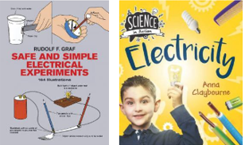

Alongside Maths, Reading and Project Work, there will be opportunity for extra-curricular activities such as Music Therapy, PE and Dance. Collaborative Friday will continue, providing opportunities for the children to develop their relationships with their “big and little friends” in Bats 1 and 3.
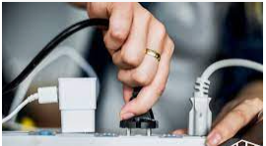

Nouns; circuit, battery, bulb, fan, buzzer, switch, wire, electricity, power, device, conductor, connection, system
Verbs; to turn on, to turn off, to make, to build, to fix, to push
Adjectives; safe, dangerous, electrical, charged, broken (open), connected (closed)
Prepositions; in, on top of
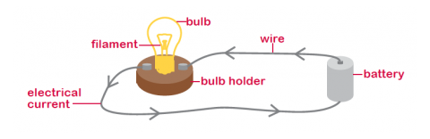

At the end of the project, the children will be able to use their knowledge of electricity to understand and explain how the lights and features at the American Museum in Bath work, as we explore the magical Enchanted Winter Wonderland around the gardens.

At home you could support your child with this new project by:
- Looking around your home -what can you see that has a plug?
- Making a list of devices you have at home that use a battery.
- Safely taking apart old electrical devices to explore the circuits inside together.
- Allowing your child to ‘tinker’ with devices (under your close supervision!) -can they make a torch work? Where is the switch and what does it use for power?
- When out in the local community, have a look for items that might be using electricity. I wonder what the wires coming from pylons are for?
- Practise using and handling electrical devices and parts safely at home. Make sure you draw attention to the precautions you take around them –e.g. ‘My hands are not wet’.
- Encourage your child to problem-solve ‘fixing’ their device when the batteries run out at home. What can they do to make it turn back on? What might they need.
A fun song all about electricity to share with your children!
https://www.youtube.com/watch?v=y1TCZh2BeMQ
Join Messy and his friends to find out how electricity travels through circuits:
https://www.bbc.co.uk/cbeebies/watch/messy-goes-to-okido-circuit-fact
Join Nina and the Neurons here:
https://www.bbc.co.uk/cbeebies/radio/radio-nina-engineering-electricity
JoJo and Gran Gran are all set for a sleepover listening to Jazz music on Gran Gran’s record player and JoJo has her favourite book with her to read at bedtime. When all of a sudden the lights go off and the record player stops working. Thankfully Gran Gran has a plan and together they get creative, cover the house in fairy lights and play board games. JoJo learns you can have just as much fun without electricity.
https://soundcarrot.com/shows/cbeebies-radio/cbeebies-jojo-gran-gran-its-time-for-a-power-cut-sleepover/
