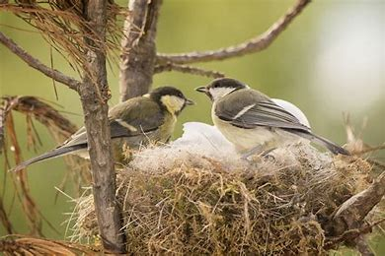

**English –** We will be reading:

The Duck who didn’t like water by Steve Small; Pip and Egg by Alex Latimer; Lost and Found by Oliver Jeffers; and Nests, Eggs and Birds by Kelsey Oseid.

We will share a variety of non-fiction books about birds and picture books which we will read daily across each week. We will join in with favourite phrases and discussions about our picture books.

**In our writing we will be learning to:**

* Use sounds to spell words, full stops, capital letters, spaces and the conjunction ‘and’ to write descriptive sentences in response to the story of ‘The Duck who didn’t like Water’, write facts about birds of prey and birds in spring, write sentences in responses to ‘Lost and Found’ by Oliver Jeffers and write about our visit to Wingfield School and the features that we noticed when walking.

**Spelling/Phonics:**

Children will be learning and applying phonic knowledge in their writing and reading.

Children will learn Year 1 common exception words, and will practise and be tested in school weekly.

**Spelling**

**Maths - We will be learning to:**

* Recognise, name and sort 2D and 3D shapes.
* Understanding place value to 20.
* Use a number line to 20.
* Compare and order numbers to 20.
* Add and subtract to 20.

**P.E.**

With Mrs Emery, the children will develop travelling, rolling, jumping and linking sequences together in gymnastics this term. They will focus on posture, performance and poise while improving their skills.

This term, we will be looking at the signs of spring arriving and how this is different to winter.

We will be finding out about lots of different types of birds, including birds of prey, river birds and birds that we see locally.

**Geography** In geography, we will use Google Earth and go on a short walk to explore the school’s locality. We will draw simple maps of our local area and compare Hilperton to Wingfield.

**Art** In Art, we will explore visual elements of tone and 3D form to create a 3D sculpture.

**Music** In music this term, children will discriminate between long and short sounds and use them to create a sequence. They will sing songs based on ‘Spring’ and will use a variety of tuned and untuned percussion instruments.

**Significant Life** We will be learning about Mary Anning, her life and why she was significant.

**Computing**

In this unit, children are introduced to early programming concepts. Children will explore using individual commands, both with other children and as part of a computer program. They will identify what each floor robot command does and use that knowledge to start predicting the outcome of programs. The unit is paced to ensure time is spent on all aspects of programming and builds knowledge in a structured manner. Children are also introduced to the early stages of program design through the introduction of algorithms.

**Science**

We will explore the different materials that objects are made of and the properties of each material. We will be sorting materials into groups and testing them to find out which will be the best to make an umbrella for the duck who didn’t like water.

**DT**

We will be learning how to do a running stitch to make a simple hand puppet.

**Personal Development**

**RE**

In RE this term, we will be focusing on Christianity. We will read stories from the Bible to find out what Christians believe Jesus was like as a friend.

**Trips and visitors**

We will visit Wingfield to find out what a village is. We will also go on another local walk to look for signs of spring.